**ABSTRACT**

Over the years, there have always been various definitions to define what eLearning really is, or how eLearning is conducted effectively as it always focusses on the specific needs of an individual or an organization. eLearning is a learning process with the combination of content that is both delivered digitally and through face-to-face learning. eLearning contributes to the shifts from traditional face-to-face learning to the use of web technological tools which enhances collaborative learning and presents an entirely new learning platform for students. The Project titled **“Virtual Academy”** is a web based application done using Php as the front-end and MySql as the back-end.Its an online learning portal for students ran by qualified live tutor’s online perfect for your children to enhance their education online. Online tutoring is an easy way to teach kids and to let them have fun while learning.The reason behind this online learning platform is the limitations or problems faced by the classroom learning methodology. Some of the limitations include  Students become overly dependent on the teacher, Classroom Size,Student Attitudes and Behaviors,difficulty in managing students etc. Your child's most valuable tool is his/her education and online tutoring is a great tool enhancer. By using Virtual Academy services you can create a fun online tutoring environment for your child. No more driving to a tutor or waiting for your tutor to come to you; by using online learning, you simply get online tutors waiting and ready to help you. Virtual Academy’s certified online tutors help kids with their homework, studying, research and other aspects of learning, schooling and education. Online learning is the use of the Internet for tutoring activities, or we can say, It is the process by which a student learns via the Internet with the help of a subject expert or a tutor.This provides great flexibility for students as  Students have the freedom to juggle their careers and school because they aren't tied down to a fixed schedule and it also reduces costs ,Online education can cost less due to a variety of reasons. Due to all these an online learning platform will be of great use in this scenario.

**ACKNOWLEDGEMENT**

If words are considered as symbols of approval and tokens of acknowledgement, then let words play the heralding role in expressing my gratitude. To bring something into existence is truly a work of God. I would like to thank God for not letting me down and showing me the silver lining in the dark clouds.

I would like to thank **Dr. Soosan George T, Principal,** Saintgits College of Engineering for his support and encouragement.

I convey my heartfelt thanks to **Dr. Rajesh K.S (**Head of the Department, Department of Computer Applications, Saintgits College of Engineering) for providing an opportunity for the project presentation.

With the biggest contribution to this report, I would like to thank my project guide **Dr.Bikku Abraham**, Professor**,** Department of Computer Applications whohad given me full support in guiding me with stimulating suggestions and encouragement to go ahead in all the time of this work.

It is my pleasure to express my gratitude to our project coordinator **Asst. Prof. Preetha S**, Department of Computer Applications, Saintgits College of Engineeringwhose support and constructive criticism has led to the successful completion of the task.

I would also thank my institution and faculty, my family and friends without whom this report would have been a distant reality.

**Cyril Cereaic Joseph**

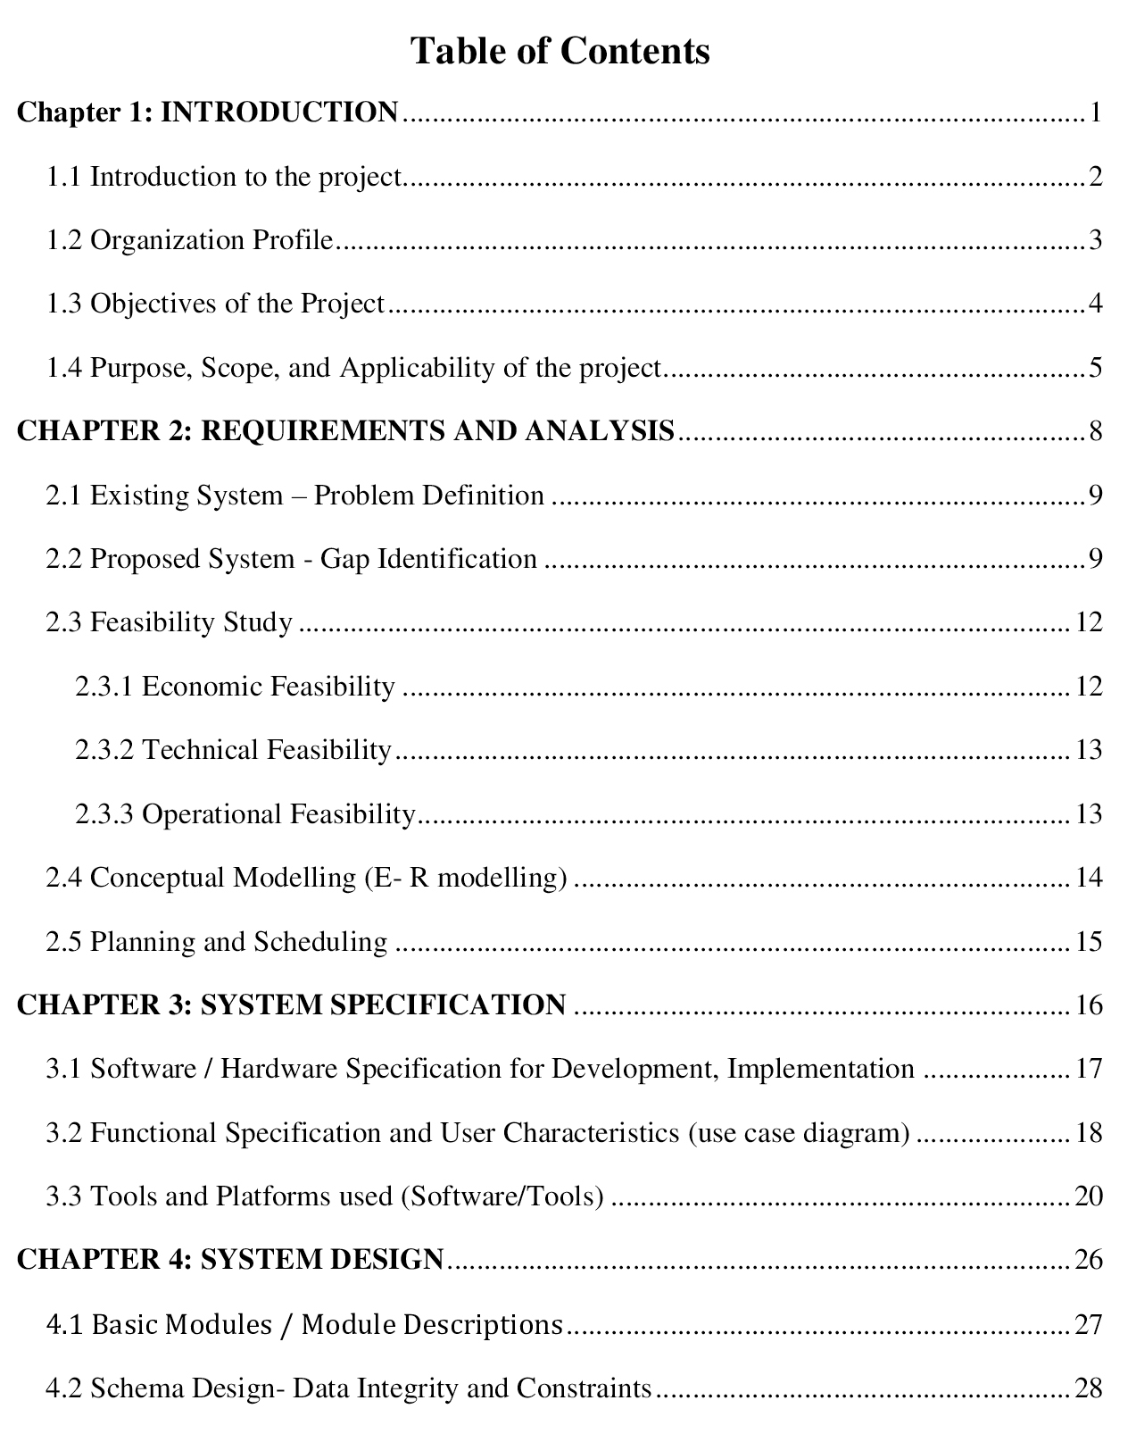

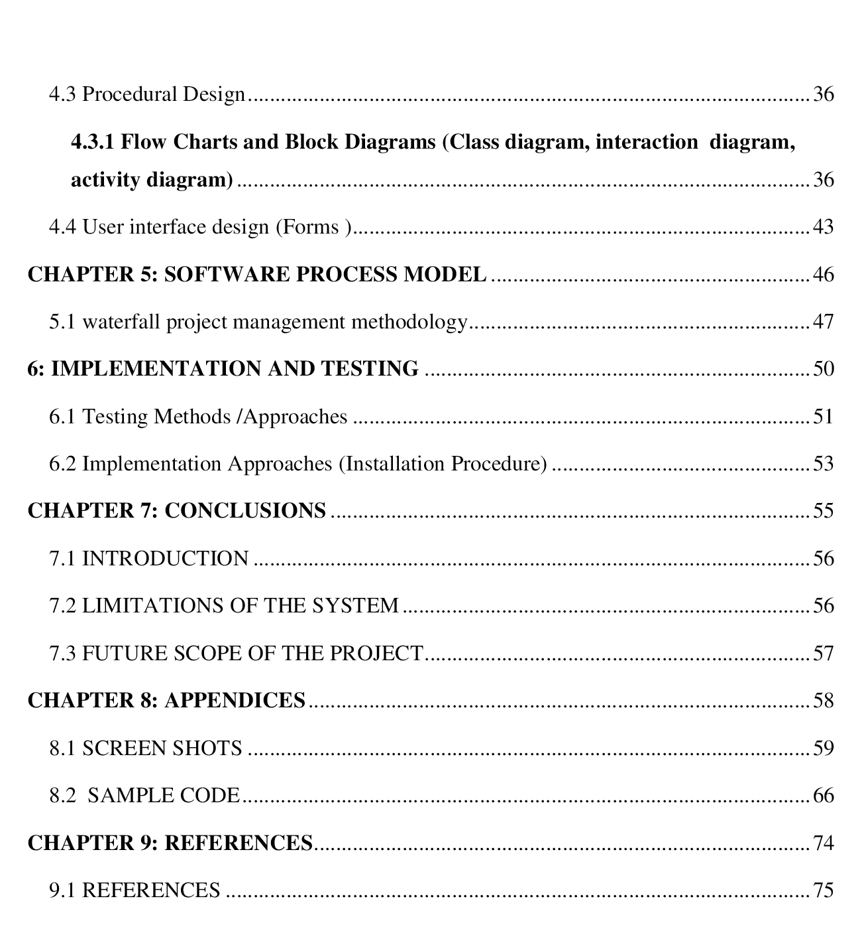

|  |  |  |
| --- | --- | --- |
| **TABLE NO:** | **LIST OF TABLES** | **PAGE**  **NO:** |

Table 4.2.1: TBL_ADMIN……………………………………………………………………………….29

Table 4.2.2: TBL_DEPARTMENT……………………………………………………………………....29

Table 4.2.3: TBL_COURSE……………………………………………………………………………...30

Table 4.2.4: TBL_SUBJECT……………………………………………………………………………..30

Table 4.2.5: TBL_TEACHER…………………………………………………………………………….31

Table 4.2.6: TBL_CLASS………………………………………………………………………………...31

Table 4.2.7: TBL_STUDENT…………………………………………………………………………….32

Table 4.2.8: TBL_TEACHER_SUBJECT………………………………………………………………..33

Table 4.2.9: TBL_FILE…………………………………………………………………………………...33

Table 4.2.10: TBL_QUESTION…………………………………………………………………………..34

Table 4.2.11: TBL_EXAM………………………………………………………………………………..35

Table 4.2.12: TBL_ACCOUNT…………………………………………………………………………..35

|  |  |  |
| --- | --- | --- |
| **FIGURE**  **NO:** | **LIST OF FIGURES** | **PAGE NO:** |

Figure 2.4.1: E-R Diagram…………………………………………………………………….14

Figure 2.5.1: Gantt chart……………………………………………………………………….15

Figure 3.2.1: Admin use case…………………………………………………………………..18

Figure 3.2.2: Teacher use case…………………………………………………………………18

Figure 3.2.3: Student use case………………………………………………………………….19

Figure 4.3.1.1:Context level dfd………………………………………………………………....38

Figure 3.3.1.2: First level dfd…………………………………………………………………....38

Figure 3.3.1.3:Registration module dfd………………………………………………………….39

Figure 3.3.1.4:Student module dfd……………………………………………………………....40

Figure 3.3.1.5:Teacher module dfd……………………………………………………………....41

Figure 3.3.1.6:Online Exam module………………………………………………………….….42

Figure 5.1.1: Phases of waterfall model………………………………………………………….47

Figure 8.1.1: Home page………………………………………………………………………....59

Figure 8.1.2: Login page ………………………………………………………………………...59

Figure 8.1.3: Student Registration…………………………………………………………….….60

Figure 8.1.4: Student Home page………………………………………………………………...60

Figure 8.1.5: Chat room…………………………………………………………………………..61

Figure 8.1.6: Study materials page……………………………………………………………….61

Figure 8.1.7: Teacher home page………………………………………………………………...62

Figure 8.1.8: Notes upload page………………………………………………………………….62

Figure 8.1.9: Question paper generation page…………………………………………………....63

Figure 8.1.10: Admin home page…………………………………………………………….….63

Figure 8.1.11: View students page……………………………………………………………….64

Figure 8.1.12: View teachers page…………………………………………………………….…64

Figure 8.1.13: Add teachers page………………………………………………………………...65

Figure 8.1.14: Add course page………………………………………………………………..…65